**CIS 572 Object Oriented System Design**

**Forward Tracing**

for

**Provider payment**



Submitted to:  Mr. Thomas Steiner

Submitted by: Vaishali Jain

**Table of Contents**

USE CASE FLOW **3**

USE CASE DIAGRAM **3**

BUILD ERD **4**

DFD **5**

COMMUNICATION DIAGRAM **5**

SEQUENCE DIAGRAM **6**

CLASS DIAGRAM **7**

CRC CARD **7**

# 1. USE CASE FLOW

* 1. **Provider Receives Payment :**

1. ChocoAn DataCenter system generates provider report including provider id and amount to be paid
2. The reports generated are written on the disk/system
3. After Midnight on friday the EFT component is triggered to read the data from the ChocoAn DataCenter System.
4. EFT credits providers bank account with the payment amount

## 

# 2. USE CASE DIAGRAM

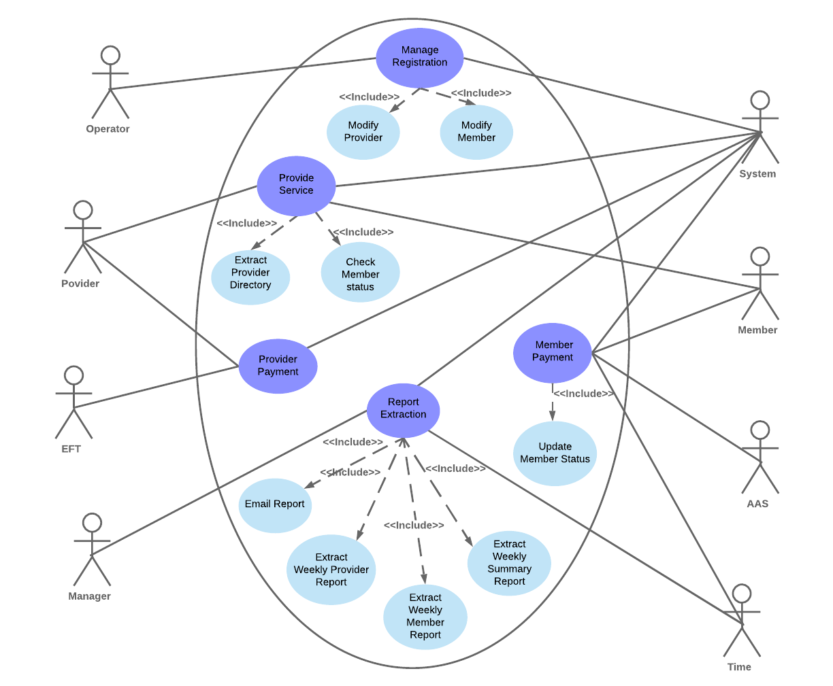

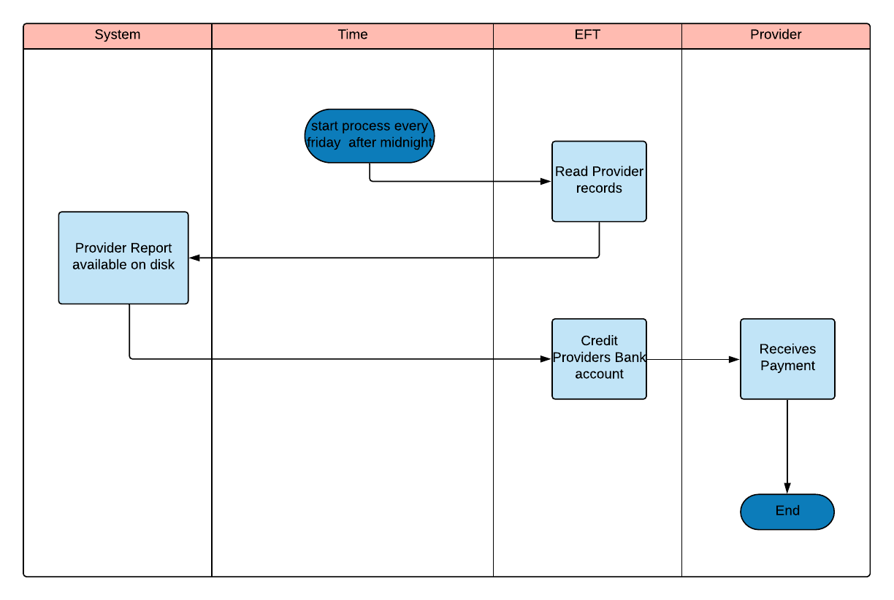

# BUILD ERD

# 

# DFD

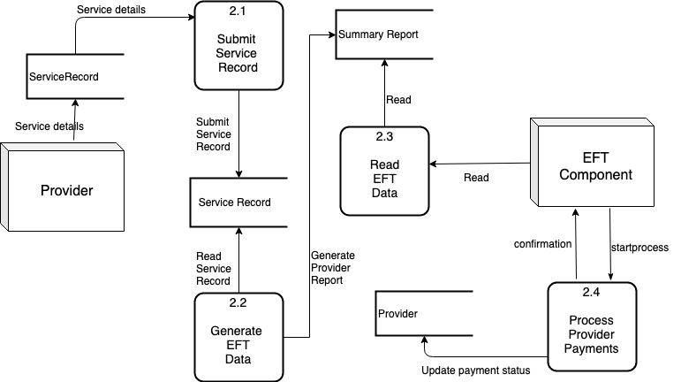

# COMMUNICATION DIAGRAM

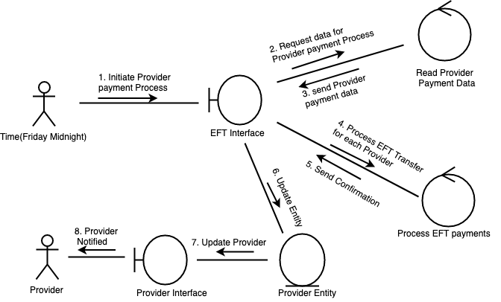

# SEQUENCE DIAGRAM

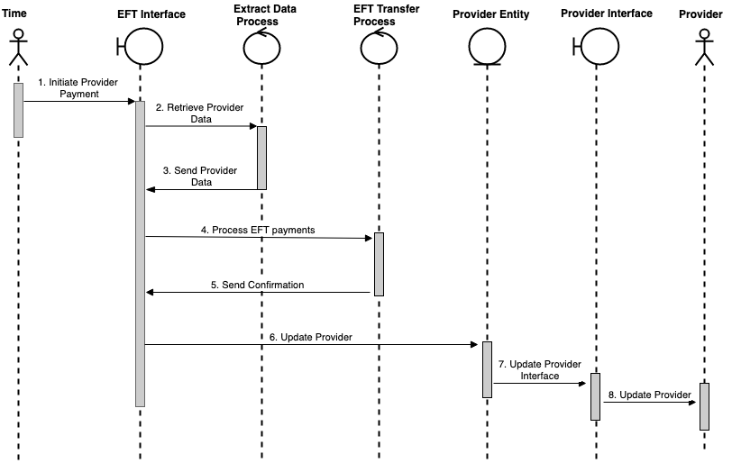

# CLASS DIAGRAM

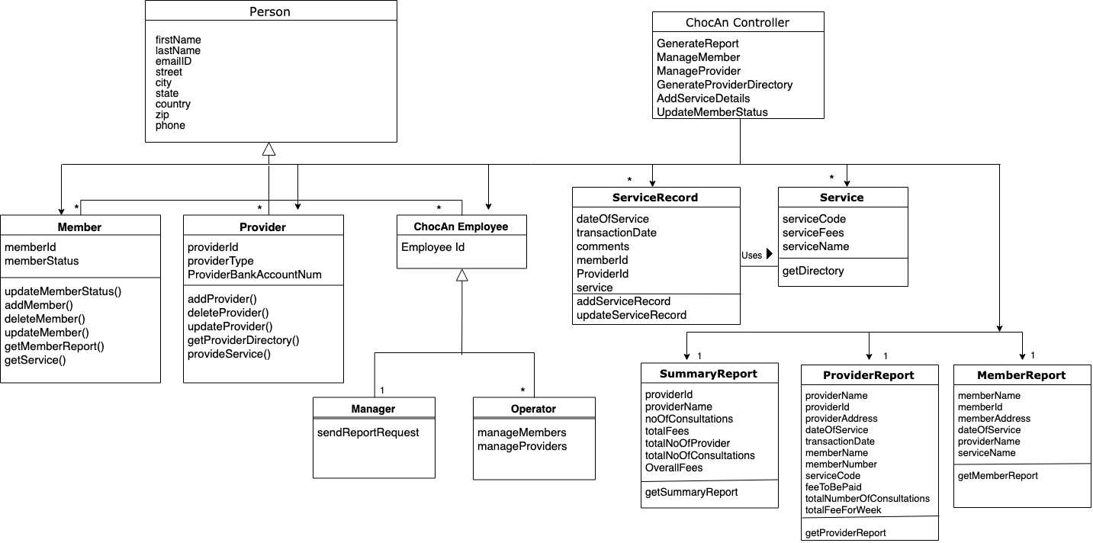

# CRC CARD

